Computer Language Coding Concepts

Executables & Executions in a Diagam
The concept of executables and executions has already been explained in the article Executables & Executions. The current article demonstrates the concept with the help of diagrams. The story of the conceptual article is repeated, but now further explaned with help of diagrams.

An executable object stands for a potential execution:

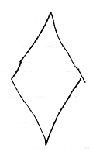

An executable object never stands for multiple executions, just one exectution or no execution at all.

A potential execution’s private contents are not created:

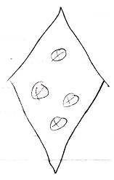

Only when it is executed for real, its private contents are created. An executable’s sub-executions are also private content of the potential execution:

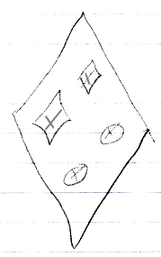

A potental execution’s public contents are its parameters, and they are created before it even runs.

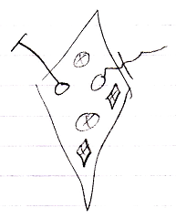

This prevents an executable object from recursively creating the calls it makes, and their calls and their calls. When the call structure would be circular, the creation process would have hung.

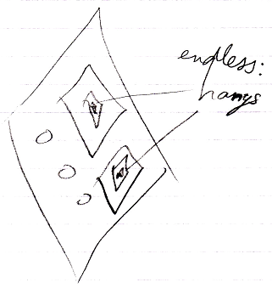

For a dormant command definition, the private command calls are also potential executions.

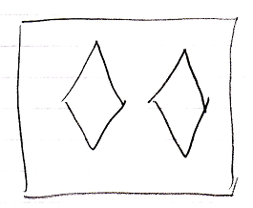

Command calls in a command definition also have their public contents created, but their private contents waiting to be created.

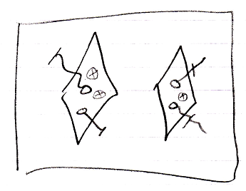

The private contents would only be created when the command definition is run for real. A command definition usually never runs at all, but it is possible for a definition itself to run, when it is referenced by an executable command reference.

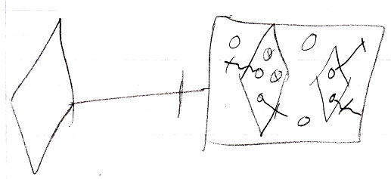

A command definition object is a potential execution, just like any other command object.

Bear in mind, that when an executable object does not redirect its definition, it has to define its own private contents, because nothing else defines its private contents but he himself. But calls inside such a definition, only have their private contents are created again.

The same command object can be displayed in the diagram multiple times. In that case, automatic containment will add a symbol to the diagram, that the multiple references to the same command object will converge to, so that a single symbol in the diagram is selected to represent the command object itself, while the other ones are just references.

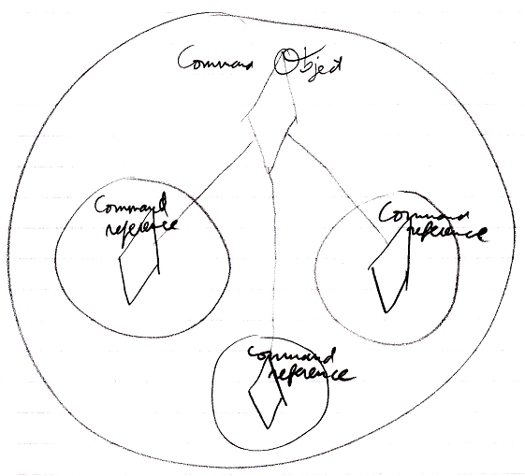

So it is not so, that each diamond in the diagram represents its own individual command execution. Each individual command object represents an individual command execution. But multiple symbols in the diagram can represent the same command object.

See also: Executables & Executions

Author & Copyright: Jan-Joost van Zon Date: August 10, 2008 – August 17, 2008 Location: Oosterhout, The Netherlands Status: Finished

